Unit 2 SQL Procedures and Views

Corey Crooks
Purdue University Global
IT350 – Advanced Database Concepts
Jason Johnson
February 15th, 2023

Problem 1: Create a stored procedure that lists the staff's last name, first name, and email address from all the company stores. The output needs to be in alphabetical order based on the last name then by the first name. The skeleton of the stored procedure is provided below.
USE BikeStores
GO

CREATE PROCEDURE GetCompanyStaffList
AS
SELECT last_name, first_name, email
FROM Sales.Staffs
ORDER BY last_name, first_name
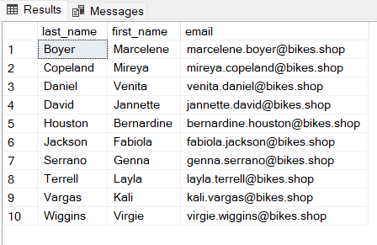

Problem 2: Create a stored procedure that lists the customers from a specified zip code. The skeleton of the stored procedure is provided below.
USE BikeStores
GO

CREATE PROCEDURE GetCustomersByZipCode
@ZipCode VARCHAR(5)
AS
SELECT *
FROM Sales.Customers
WHERE zip_code = @ZipCode;

EXEC GetCustomersByZipCode @ZipCode = '75115';
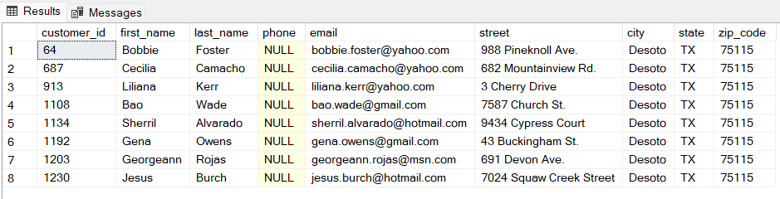

Problem 3: Create a stored procedure that lists mountain bikes for a specified brand. The output must show the bike name, model year, and list price. The results need to be presented in alphabetical order based on the bike name. The skeleton of the stored procedure is provided below.
USE BikeStores
GO

CREATE PROCEDURE GetMountainBikesByBrand
@Brand VARCHAR(255)
AS
SELECT product_name, model_year, list_price
FROM Production.Products P INNER JOIN Production.Brands B
ON P.brand_id = B.brand_id
INNER JOIN Production.Categories C
ON P.category_id = C.category_id
WHERE C.category_name = 'Mountain Bikes'
AND B.brand_name = @Brand
ORDER BY product_name;

EXEC GetMountainBikesByBrand @Brand = 'Haro';
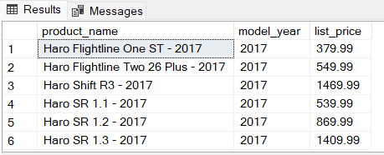

Problem 4: Create a stored procedure that lists bikes within a specified price range. The output must show the bike name, model year, and list price. The results need to be presented in alphabetical order based on the bike name. The skeleton of the stored procedure is provided below.
USE BikeStores
GO

CREATE PROCEDURE GetBikesByPriceRange
@MinPrice Decimal(10,2), @MaxPrice Decimal(10,2)
AS
SELECT product_name, model_year, list_price
FROM Production.Products
WHERE list_price BETWEEN @MinPrice AND @MaxPrice
ORDER BY product_name;

EXEC GetBikesByPriceRange @MinPrice=6000, @MaxPrice=12000; 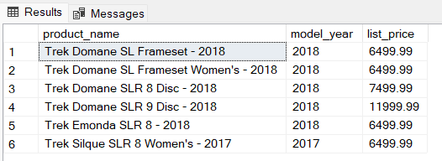

Problem 5: Create a stored procedure that lists the top five priced bikes at a specified store. The output must show the bike name, model year, and list price. The results need to be presented in descending price order. The skeleton of the stored procedure is provided below.
USE BikeStores
GO

CREATE PROCEDURE GetTopFivePricedBikesByStoreName
@StoreName VARCHAR(255)
AS
SELECT TOP 5 product_name, model_year, list_price
FROM Production.Products PR INNER JOIN Production.STocks SK
ON PR.product_id = SK.product_id
INNER JOIN Sales.Stores ST
ON SK.store_id = ST.store_id
WHERE store_name = @StoreName
ORDER BY list_price DESC;

EXEC GetTopFivePricedBikesByStoreName @StoreName='Baldwin Bikes';
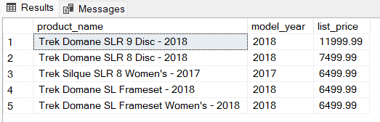

Problem 6: Establish a database view called CompanyStaffListView that lists the last name, first name, and email address of the staff from all the company stores. Then execute a SELECT query to verify the view.
USE BikeStores
GO

CREATE VIEW CompanyStaffListView
AS
SELECT last_name, first_name, email
FROM Sales.Staffs;

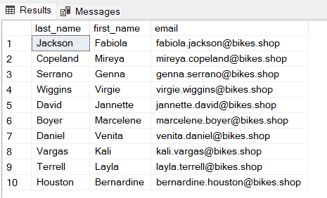

Problem 7: Establish a database view called BuffaloCustomersView that lists the last name, first name, and email address of customers that live in the city of Buffalo, NY. Then execute a SELECT query to verify the view.
USE BikeStores
GO

CREATE VIEW BuffaloCustomersView
AS
SELECT last_name, first_name, email
FROM Sales.Customers
WHERE city = 'Buffalo' AND state = 'NY';
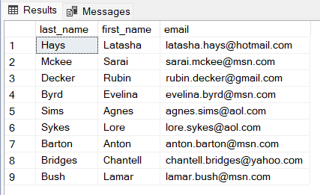

Problem 8: Establish a database view called LowRowlettBikesInventoryView that lists the bikes with stock levels less than 2 at the Rowlett Bikes store. The view needs to contain the bike name, brand name, and stock quantity amount. Then execute a SELECT query to verify the view.
USE BikeStores
GO

CREATE VIEW LowRowlettBikesInventoryView
AS
SELECT product_name, brand_name, quantity
FROM Production.Products PR INNER JOIN Production.Stocks SK
ON PR.product_id = SK.product_id
INNER JOIN Sales.Stores ST
ON SK.store_id = ST.store_id
INNER JOIN Production.Brands BR
ON PR.brand_id = BR.brand_id
WHERE store_name = 'Rowlett Bikes'
AND SK.quantity <2;
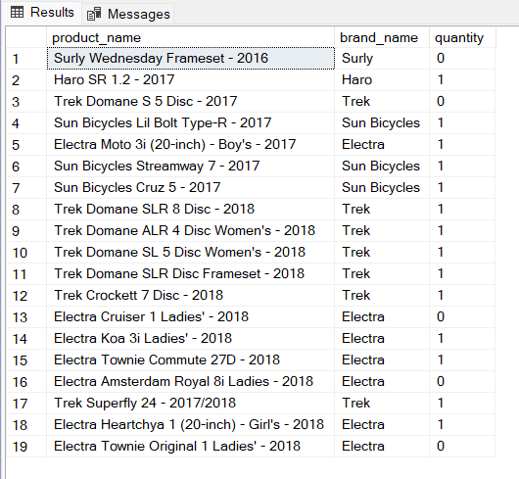

Problem 9: Establish a database view called LowCostBikesView that lists the bikes costing $200 or less. The view needs to contain the bike name, brand name, and list price. Then execute a SELECT query to verify the view.
USE BikeStores
GO

CREATE VIEW LowCostBikesView
AS
SELECT product_name, brand_name, list_price
FROM Production.Products PR INNER JOIN Production.Brands BR
ON PR.brand_id = BR.brand_id
WHERE PR.list_price <= 200;
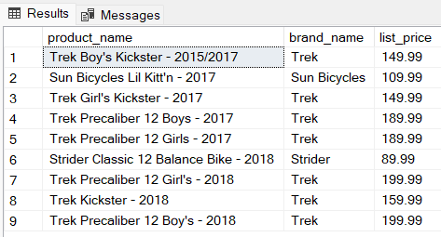

Problem 10: Establish a database view called UnshippedRowlettBikesOrdersView that lists the orders that have not been shipped. The view needs to contain the order ID, customer first name, customer last name, and order date. Unshipped orders are signified by order_status = 1. Then execute a SELECT query to verify the view.
USE BikeStores
GO

CREATE VIEW UnshippedRowlettBikesOrdersView
AS
SELECT order_id, first_name, last_name, order_date
FROM Sales.Orders OD INNER JOIN Sales.Customers CR
ON OD.customer_id = CR.customer_id
INNER JOIN Sales.Stores ST
ON OD.store_id = ST.store_id
WHERE ST.store_name = 'Rowlett Bikes'
AND OD.order_status = 1;
